Final thesis – VCT
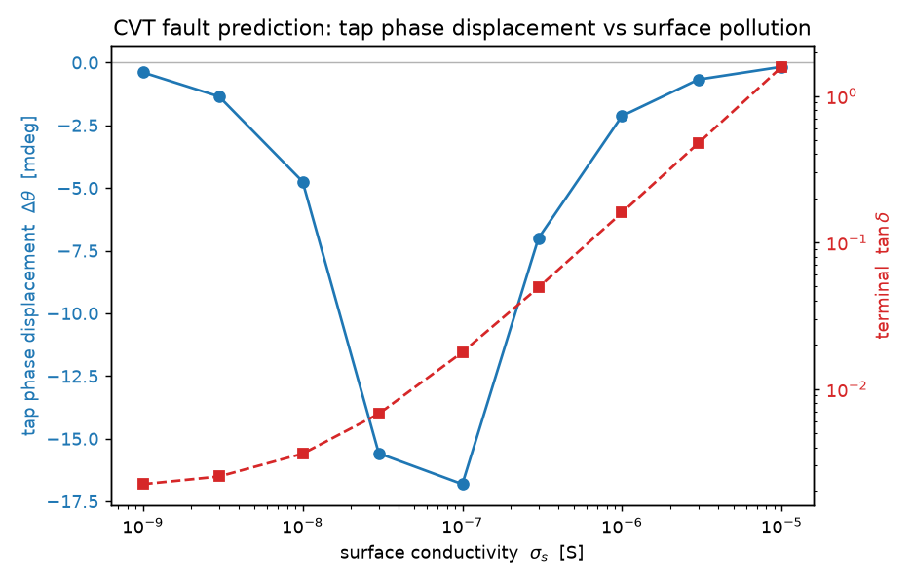
- Surface conductivity – Tuleb standardist IEC 60815 (Selection and dimensioning of high-voltage insulators intended for use in polluted conditions). 10
^-9 S represents perfectly clean, dry porcelain surface in a rural environment. While 10^-5 S represent a heavily polluted surface coated in wet, conductive sea-salt or inductrial soot. S stands for Siemens. We got the results by using python script „python scripts/phase7_cvt.py --phase-sweep“ which took 3D mesh, assigned σs​= 10⁻⁹ to porcelain surface, solved matrix and saved results, erased results and changed boundary to 10^-8, solved again and so on.
- Tan δ aka energy loss – current flowing through an insulator is sum of two parts, capacitive charging current (Ic) and resistive leakage current (Ir). Loss angle describes the ratio between these two currents. Tan phi = 1 means that resistive leakage current is equal to capacitive displacement current. Physically means insulator is acting equally as resistor and capacitor, at this point massice amounts of energy are being burned off as heat across the surface of the transformer, which is severe and highly dangerous state.
  - $\tan{δ}= \frac{I_{R}}{I_{C}}=\frac{G}{ωC}$, kus G on conductance of pullution layer ja w on 2pi*f ja C on mahtuvus.
- Δθ aka phase displacement – Phase displacement measures how much the AC waveform’s timing is twisted as it travel through the transformer. It is phase angle difference between primary HV line entering topp of transformer (Vp) and the secondary voltage tap leaving the bottom (Vs). In FEA solver outputs voltage at the tap as complex number consisting real part (Vre) and imaginary (Vim)
  - $θtap=\arctan{(\frac{V_{im}}{V_{re}})}$
- Idee: Võtta tuletis mõlemast funktsioonist pinna mustuse suhtes d/dσ ​(tanδ) ja d/dσ ​(Δθ).
  - Tuletis tanδ on positiivne konstant kuna see on lihtsalt tõusev kurv
  - Tuletis faasinihkest Δθ on sisukam:
    - Kui on negatiivne siis trafo saab mustemaks
    - Kui on 0 siis on graafiku põhjas, see peaks olema kriitilisuse punkt
    - Kui on positiivne siis ta on juba läbinud point of no returni ja dominated by resistive short-circuiting.
  - Kuna mõlemad liiguvad samal ajal aga erinevad tempos niiöelda siis peaks neid mitte võtma eraldi vaid samal ajal, kuna neil sama input siis selle nimi peaks olema parametric equation, võttes nende tuletime samal ajal teeb state-space trajectory vector.
    - $v= \frac{d(Ratio Error)}{dσ_{s}},\frac{d(Phase Shift)}{dσ_{s}}$
  - See annab vektori mis näitab mis suunas ja kui kiiresti rikkelisuseks liigub.
  - 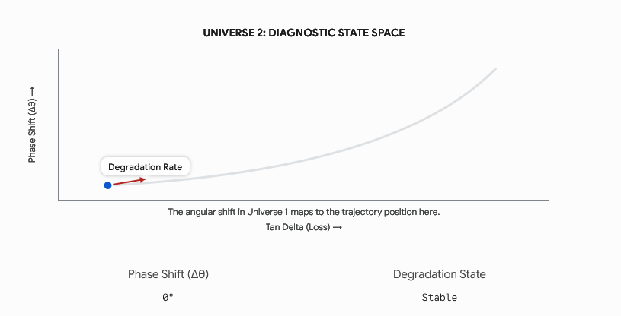
  - Võttes uue vektori mapi mis me ehitasime (või ehitan veel) (ratio error vs phase displavement) on phase-space diagram. Sellega seondub mittelineaarne dünaamika… kas siin võib olla kaost?
  - Degration path (pollution sweeps, misture ingress) on äärmiselt mittelineaarne kuid mitte kaootiline, selleks, et kaootiline olla peab olema ta tundlik algsetele tingimustele (initial conditions, butterfly effect). Kui mul on kaks täiesti puhast trafot ja ma panen neile mõlemale samad pollutionid siis nad liiguvad sama ettearvatavat trajektoori kuni nad jõuavad point attractorini.
  - Mis on kaootiline on „ferroresonants“. Kuigi trafo kulumine ise ei ole siis elektriühendus sees võib olla. Inductive voltage transfotmer in the bottom tank has iron core, iron cores saturate electromagnetically making them nonlinear inductors. In physics when you Connect nonlinear inductor, a capacitor (C1 and C2) and periodic driving force (50 Hz AC grid) you create the duffing oscillator.
  - Antud lõputöö raames see midagi juurde ei anna.
    - This thesis maps the stable state-space trajectory of environmental degradation. However, a CVT is a forced nonlinear oscillator. Future predictive algorithms must distinguish between the slow trajectory of physical degradation (a point attractor) and sudden grid transients like ferroresonance (a strange attractor).
- Valemeid:
  - 1. The Foundational Physical Model (The Admittance)
  - The pollution layer on the 2D surface of the porcelain sheds acts as a purely resistive conductance (G) in parallel with the baseline capacitance (C) of the transformer.
  - First, we define the conductance as a function of your surface conductivity (σs​):
  - G(σs​)=k⋅σs​
  - Where k is the geometric form factor of the insulator (derived from the 3D mesh surface area and creepage distance).
  - The total complex admittance (Y) of the degraded system is:
  - Y=G(σs​)+jωC=kσs​+jωC
  - (Where ω=2πf is the angular grid frequency).
  - 2. Deriving the Energy Loss (tanδ)
  - The dielectric loss tangent (tanδ) is defined as the ratio of the real (resistive) part of the admittance to the imaginary (capacitive) part.
  - tanδ(σs​)=Im(Y)Re(Y)​=ωCkσs​​
  - To find how fast the energy loss is growing, we take the first derivative with respect to pollution:
  - dσs​d​(tanδ)=ωCk​
  - Thesis Note: Because k, ω, and C are all positive constants, this derivative is a positive constant. This proves mathematically why your tanδ graph is a steadily rising straight line.
  - 3. Deriving the Phase Displacement (Δθ)
  - The phase shift caused by the surface leakage can be modeled as an electrical relaxation process (similar to Debye relaxation). The phase angle twist (Δθ) follows a non-monotonic curve driven by the ratio of conductance to susceptance.
  - For simplicity, let x be our tanδ ratio (x=ωCkσs​​). The phase displacement function is:
  - Δθ(σs​)=A[1+x2x​]
  - (Where A is a scaling coefficient specific to the DDB-123 voltage divider network).
  - To find how fast the phase angle is twisting, we take the derivative using the quotient rule:
  - dσs​d​(Δθ)=dxdΔθ​⋅dσs​dx​
  - First, apply the quotient rule to the relaxation peak:
  - dxd​[1+x2x​]=(1+x2)21(1+x2)−x(2x)​=(1+x2)21−x2​
  - Now, multiply by the inner derivative (dσs​dx​=ωCk​):
  - dσs​d​(Δθ)=A(ωCk​)​(1+(ωCkσs​​)2)21−(ωCkσs​​)2​​
  - Thesis Note: This equation is the mathematical proof of your "Early Warning System."
  - When pollution is low (x<1), the numerator (1−x2) is positive, meaning the phase is shifting rapidly.
  - When pollution hits the exact critical threshold (x=1), the numerator becomes (1−1=0). The derivative is exactly zero, creating the bottom of the "U-shape" peak on your graph.
  - When pollution is high (x>1), the numerator becomes negative, and the phase shifts back toward zero.
  - 4. The State-Space Trajectory Vector (v)
  - Now that we have both independent rates of change, we combine them into a single parametric vector in diagnostic phase space. This vector describes the exact instantaneous trajectory (velocity and direction) of the transformer's degradation.
  - v=(dσs​d(tanδ)​;dσs​d(Δθ)​)
  - Substituting our derived equations into the vector format:
  - v=​ωCk​;AωCk​​(1+(ωCkσs​​)2)21−(ωCkσs​​)2​​​
  - By factoring out the common constant (ωCk​), we get the final, elegant form for your methodology chapter:
  - v=ωCk​(1;A[(1+x2)21−x2​])
  - The State-Space Trajectory Vector (v) demonstrates that standard scalar limits (like a static threshold for tanδ) are insufficient for predictive maintenance. By calculating this vector in real-time, the algorithm evaluates the instantaneous direction of degradation in diagnostic phase space. A zero-crossing in the second vector component (v2​=0) mathematically guarantees that the system has reached the point of maximum capacitive reactance, serving as an absolute trigger for maintenance intervention prior to resistive flashover.
- Väike tähelepanek, kriitiline punkt juhtub „intermediate voltage tap (connection between C1 ja C2 vahel) peal, kuid see on peidetud secondary terminalil sellepärast compensatsioonireaktor silub selle ära.
  - Statespace.csv failis on näha, et tap_dtheta_mdeg liigub 0st -19 mdeg ja tagasi 0 juurde ehk tekib U kurv.
    - Mis asi on tap_dtheta_mdeg? See on pinge mõõdetud täpselt juhtmelt mis ühendab C1 ja C2 kondekad
  - Sec_phase_arcmin algab 0,0003, tõuseb 0,4 ja jätkab tõusmist kuni 3,35ni ehk tavaline sirge.
    - Mis see on? See on pinge mõõdetud väljundklemmidel trafo põhjast.
  - Mida see tähendab või miks siis sekundaar terminal peidab viga? Põhjuseks on see mis on selle vahel. Selle vahel on kompenseeriv reaktor (induktor, L). Reaktor on täpselt nii seadistatud, et ta canceldaks mahtuvuse ära (wL = 1/ wC_eq).
    - Kui saaste (pollution) läheb isolaatorite peale, see annab resistive leakage pathi. Tap-i juures on paralleelne RC circuit, mis toodab selle complex U-kurvi (relacation peak), kuid when twisted signal is forced through tuned reactor, the massice inductor fights phase shift. It acts like an electrical shock absorber. The inductor methematically linearizes the signal, smoothing out the early warning U-shape into a slow, monotonic crawl.
    - 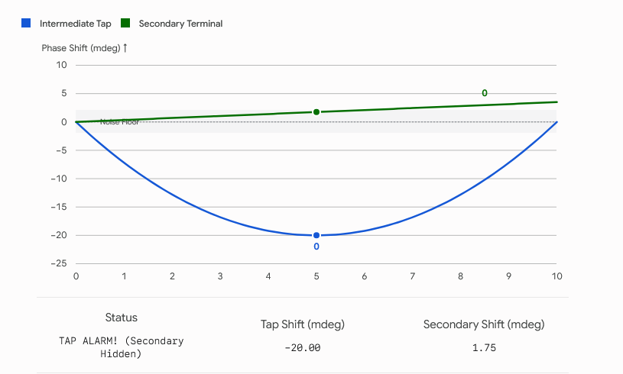
    - Siin on näha, et kui TAP-il on kriitilises punktis (-20 mdeg) siis terminali juures on see kõigest 0 juures.

- Phase shift (timing) graafik
- 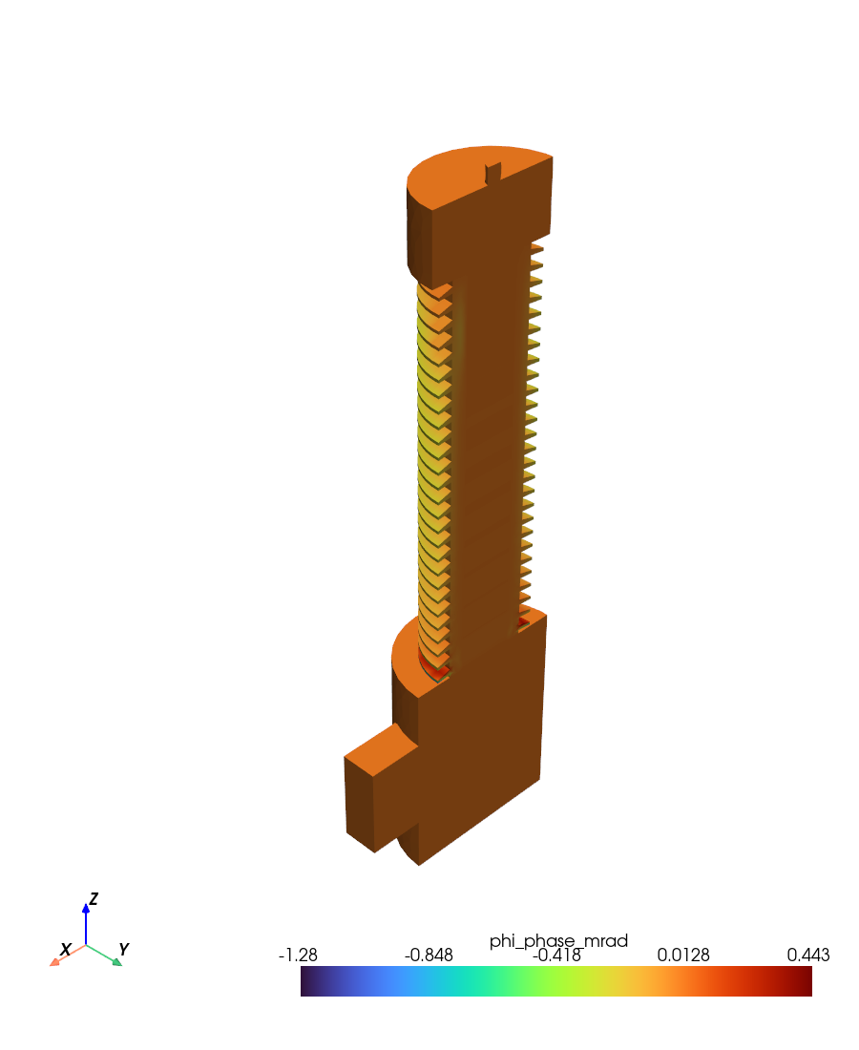
- Mida see näitab?
  - AC voltage nihet, me näeme, et enamus trafost on normaalne, kuid rõngas põhjas on 0,443 juures mis näitab, et kui ülelöök tekib siis pigem alumiste rõngaste juurest otse tanki.
- Detectability_threshhold
  - Näitab piire millest alates võiks öelda, et tegemist on rikkega.
    - Nt internal moisture thrshold =4,0% base C rise. Loogika sellest, et kui paber isolatsioon kulub siis mahtuvus tõuseb, kui see tõus on 4,0% siis võib öelda, et tegemist on rikkega mitte lihtsalt kuum suvepäev mis mõjutab õli temperatuuri jms.
Structure:
What to do instead: The Thesis Outline
You have all the data. Your only job now is to put it into a Word document. Here is the exact structure your thesis should take, mapped directly to the files sitting in your Thesis_Data_Final folder:
The Blueprint: Adapting the Sample Structure
Front Matter
- Abstract & Annotatsioon: A one-page English summary and its Estonian translation. We will write this absolute last, once the rest of the thesis is locked in.
- Abbreviations: e.g., FRC becomes CVT, ODF becomes PMU, FEA, EQS (Electroquasistatic), etc.
1. Introduction
- The Context: The reliance on Capacitive Voltage Transformers (CVTs) in modern high-voltage grids.
- The Problem: The operational blind spots causing Elering and municipal control rooms to register catastrophic flashovers as "Indefinite Faults."
- The Objective: Developing a 3D FEA digital twin to map environmental degradation and establish a predictive state-space trajectory.
2. Theory
- This replaces Artur’s fiber generation theory with your electromagnetics.
- The Voltage Divider: The classical RC parallel circuit math (Vtap​=Vp​[C1​+C2​C1​​]) and how physical degradation unbalances it.
- The Observables: Deriving the equations for energy loss (tanδ) and phase displacement (Δθ).
- Surface Conductivity (σs​): Defining the IEC standards for pollution and the physics of the equipotential zone.
3. Implementation (Methodology)
- This is where you explain the pipeline your AI agent built.
- The 3D FEA Model: Detailing the 192,000-tetrahedron mesh and boundary conditions.
- Parameter Sweeps: How the Python scripts iteratively altered the 2D surface conductivity boundary from 10−9 S to 10−5 S.
- The State-Space Vector: Defining the combined parametric derivative (v=[dσs​d(tanδ)​;dσs​d(Δθ)​]).
4. Results
- This mirrors Artur’s Chapter 4, relying entirely on the artifacts sitting in your final data folder.
- The Noise Floor: Presenting the detectability_thresholds.csv to prove internal shorts are 130× above the weather drift envelope.
- The Relaxation Peak: Showcasing the U-shaped phase shift curve for uniform pollution.
- The Invisible Fault: Dropping the view3d_streamer.png mic-drop to prove why the stork streamer creates a 0 mA physical leakage blind spot.
- The State-Space Trajectory: Presenting the final dashboard curves and velocity vectors.
5. Summary (and Practical Implementation)
- The Conclusion: Summarizing the findings and explaining the "masking effect" of the compensating reactor.
- The Engineering Recommendation: The decision tree classifier and the requirement for intermediate tap monitoring.
- Future Work: Explicitly carving out ferroresonance and the Duffing oscillator as nonlinear, chaotic transients outside the scope of this static manifold.
Appendices
- Appendix 1: Non-exclusive license (Standard TalTech form).
- Appendix 2: phase9_statespace.py and any other critical Python processing scripts.
- Appendix 3: Core FEA solver input parameters or configurations.

